WEST END LITTLE LEAGUE

SAFETY MANUAL

MANAGER & COACH GUIDE

www.westendlittleleague.org

REVISED January 2021

Table of Contents
Table of Contents 3
The Little League Pledge 5
The Little League Parent & Volunteer Pledge 5
West End Little League Objectives 5
League Contact Information 6
Covid Safety Plan 7
Safety Manual & Equipment Requirement 10
Important Safety Dates 11
Non-Emergency Contacts 12
West End Little League Code of Conduct & Standards 13
Concession Stand Safety 14
Food Handlers 14
Insects And Vermin 14
Refrigeration and Freezing 15
Cooking to Proper Temperatures 15
Microwave Cooking Instructions 15
Reheating 16
Use Disposable Containers, Utensils, Napkins 16
Cleaning and Sanitation 16
Separating 16
Parent Code of Conduct 18
Manager and Coach Code of Conduct 19
West End Little League Manager Responsibilities 21
West End Little League Coach Responsibilities 22
Information on Concussions 24
Safety Inspection 26
Safety Code / Tips 27
First Aid Tips 28
Red Cross First Aid Tips 31
Accident Reporting Procedures 34
Accident Notification Form & Instructions 35
Communicable Disease Procedures 37
Dental Injuries 38
Weather Safety 39
Child Protection Program and Volunteer Application Form 41
Tips, Drills, & Information for Coaches 44
Conclusion 52

The Little League Pledge

I trust in God
I love my country and will respect its laws
I will play fair and strive to win
But win or lose, I will always do my best

The Little League Parent & Volunteer Pledge

I will teach all children to play fair and do their best.
I will positively support all managers, coaches, and players.
I will respect the decisions of the umpires.
I will praise a good effort despite the outcome of the game.

West End Little League Objectives

The objective of the West End Little League is to promote the ideals of honesty, loyalty, trust, good sportsmanship, fair play, and respect for authority, in order to help our children prepare for adulthood.
These objectives are accomplished by stressing several important positive factors in the coaching process, while avoiding the tendency of “playing your better players only” and “winning above all else”.

League Contact Information
League Website:
www.westendlittleleague.org
League Phone:
570-243-9976
League Mailing Address:
PO BOX 1051
Effort, PA
18330

How to contact any member of the Board of Directors: our contact information is always available to you on our website: click on “About Us” and “Board of Directors” to find the person you need. The website will always display the most up-to-date contact information.

At the beginning of season, please check to make sure you know who you should contact regarding any issue/concern that may arise (e.g., Player Rep, Safety Officer, Equipment Manager, etc.).

Please use the space below to record any numbers or email information pertinent to your season:

West End Little League Covid-19 Safety Plan

Community youth sports activities require unique consideration during the COVID-19 pandemic. After reviewing the COVID-19 Prevention Checklist for Community Sports provided The Center for Disease Control (CDC) as well as guidance by the State of Pennsylvania and after carefully studying and discussing the multiple challenges to effective prevention strategies presented by playing games of baseball and softball ,the Board of Directors for West End Little League has developed the following Covid 19 specific Safety Plan.

We adopt the following new rules and procedures fully expecting to make necessary adjustments, with input from parents, coaches, and players, as we go forward with practices and games. In each of our divisions before actual games begin,every Manager, Coach, Team Parent and Umpire will attend a required safety meeting where Covid 19 rules will be reviewed. Each team will participate in at least one practice prior to the start of games, during which coaches will take the time to stop play and thoroughly review all social distancing and equipment sanitizing requirements with the players and the spectators.

Fields and Facilities

1) No more than 50 players, coaches, and spectators shall occupy the playing field, the area immediately behind the home plate backstop fence, and the area outside the fences along the right and left field sidelines. (If field space allows)
(This can and will be adjusted as Federal and State Guidelines dictate)
2) Additional spectators whose numbers would exceed the 50-person limit shall be required to remain behind the outfield fence (If field space allows)
(This can and will be adjusted as Federal and State Guidelines dictate)
3) The outfield fence or area designated as such or where space is available, shall be considered a separate area and no more than 50 spectators may be in that area at the same time. (This can and will be adjusted as Federal and State Guidelines dictate)
4) A parent/ guardian will receive an email with a safety link to complete prior to every practice or game regarding the policy that no one should attend or participate in a practice or a game if they currently have symptoms or have been in contact with anyone with a confirmed COVID-19 diagnosis in the last 14 days. (This can and will be adjusted as Federal and State Guidelines dictate)
5) Dugouts (where available) will be off limits to teams during practices and games. Expanded dugouts will be established along the rightfield and left-field sideline fences from the dugout gate to the outfield corner. Each player will be asked to identify an area 6 feet from the nex player and to utilize that same area for both practices and games. A player’s equipment bag and water bottle must remain in his or her designated area at all times. (This can and will be adjusted as Federal and State Guidelines dictate)
6) When a player is not in the field in a defensive position, and not on base, at bat, or on deck, he or she must be positioned in the designated area at a safe, 6-foot distance from teammates (This can and will be adjusted as Federal and State Guidelines dictate)
7) During practices and games, the on-deck hitter will be the only one allowed to enter the dugout area. (This can and will be adjusted as Federal and State Guidelines dictate)
8) Coaches must disinfect the dugouts (where dugouts are present) before and after every game and practice. Spray sanitizer will be supplied by West End Little League. (This can and will be adjusted as Federal and State Guidelines dictate)
9) The Snack/ Food will be evaluated prior to each game and in accordance with the current CDC, State and Local guidelines at that time decisions will be made as to whether it will be in operation. If open, patrons will be asked to wait in line at minimum 6 feet apart. If safety protocols from the CDC, State or Local guidance recommends not utilizing the snack/food area the building will remain locked and closed.
10) Portable restroom facilities. Coaches will be responsible for leaving hand sanitizer near the entrance as well as sanitizing the entrance and the interior before and after each game or practice. An ample supply of sanitizing spray and hand sanitizer will be stored in the equipment shed at each field.
11) The announcers/score booth if available at the field will be closed and off limits to players and spectators for the entire season.

*Total numbers may change based on current safety guidelines

Safely Managing Equipment, Practices, and Games for Players, Managers, Coaches and Volunteers.

1) Coaches, players, and parents should self-screen for COVID-19 symptoms before coming to the field. Anyone exhibiting symptoms may not attend or participate in a practice or a game. Symptoms include cough, shortness of breath or difficulty breathing, chills, repeated shaking with chills, muscle pain, headache, sore throat, loss of taste or smell, diarrhea, fever or feeling feverish, known close contact with a person who has been lab-confirmed to have COVID-19.
2) Player equipment shall not be shared. Each player should provide his or her own helmet, fielder’s glove, catcher’s gear, batting gloves and baseball/softball bat. If a player is unable to furnish their own equipment it can be provided by the league for the player to use only and for the entire season
3) Full sets of catcher’s gear will be provided to each team for the season. Catcher’s equipment must never be shared during a game.
4) Coaches will be responsible for disinfecting catcher’s gear after each game if the equipment will be utilized by a different player for the next game or practice. Coaches may decide to designate catchers for the entire season and allow each catcher to manage his or her own set of catcher’s gear for the season.
5) Players will be encouraged to keep a personal bottle of hand sanitizer in their equipment bags. Hand sanitizer will be considered necessary baseball equipment this year.
6) All players will be encouraged to use hand sanitizer when entering the facility. Players will be encouraged to use hand sanitizer between innings as a habit.
7) All baseballs and softballs will be used only for their team and will not be shared. Each team will be responsible for providing the balls for their team to use.
8) No handshakes or fistbumps among players coaches after a game. No spitting. No sunflower seeds.
9) Every coach must use a face mask when coming into close contact to another coach or player.
10) All coaches must wear face masks during team meetings and maintain 6 foot social distancing where 6 foot social distancing can be achieved.
11) Practices will be managed in small groups of 4 or 5 players whenever possible. Players while in rotation through various drills: infield, outfield, batting cage practice, pitching, etc.will be required to maintain social distancing.
12) During games the dugouts will be used only for the batter who is on-deck and Coaches.
13) Umpires will make the decision as to whether or not to call balls and strikes from behind home plate or from behind the pitcher’s mound, with a face mask available for when they may need to come into extended close contact with a player or coach while explaining a ruling.
14) In general, coaches will be responsible for ensuring that social distancing is maintained between players as much as possible. This means additional spacing between players while playing catch, changing drills so that players remain spaced out, and no congregating of players while waiting to bat.
15) Players must bring their own water or other beverage to consume during and after practice. No shared drinking fountains, portable hydration stations, or coolers may be used.
16) In the event that any player, parent, guardian, family member, coach or league official has a positive Covid 19 test or has close contact with someone who may have had a positive test or displayed Covid symptoms the West End Little League Safety Officer and League President should be notified immediately. The Safety Officer and President will collaborate regarding next steps which may include contact tracing and the decisions regarding if practices or games will be cancelled. No one who believes they have had exposure should attend any games or practices and follow CDC quarantine guidelines until a test result is obtained. An email will be sent league wide informing of the situation but will not offer any identifiable information.

Spectators
1) Spectators may position themselves along the outfield fence while maintaining the required social distancing and complying with Pennsylvania’s 50-person limit for social gatherings Coaches will be responsible for not allowing spectators behind the home plate backstop fence. (This can and will be adjusted as Federal and State Guidelines dictate)
2) Spectators may not watch games or practices from the sideline fences between the dugout gate and near the expanded dugout areas for players and coaches. They must remain behind these designated player and coach areas. (This can and will be adjusted as Federal and State Guidelines dictate)
3) Spectators must wear face masks when they do not maintain 6 feet of separation from other spectators. (This can and will be adjusted as Federal and State Guidelines dictate)
4) If coaches or league officials judge that spectators are not following social distancing safety guidelines sufficiently, or any of the safety rules, play will be suspended until they comply.
5) If too many spectators attempt to attend games, coaches will be asked to devise a sign up sheet to limit the total number of spectators in the separate outfield area to no more than 50. (This can and will be adjusted as Federal and State Guidelines dictate)
6) Whenever possible, spectators should allow a player or a coach to retrieve a foul ball or home run ball.

*Total numbers may change based on current safety guidelines

Reference Little League Guidelines
https://www.littleleague.org/player-safety/coronavirus-update/season-resumption-guide/prepare/asap-guidance-for-2021-season/

https://www.coronavirus.gov/

https://www.cdc.gov/coronavirus/2019-ncov/community/schools-childcare/youth-sports.html

West End Little League Board of Directors

Safety Manual & Equipment Requirement

All volunteers must have a printed copy of this manual. You will be given one printed copy. Additional copies are available on the league website: www.westendlittleleague.org. THE FIRST AID KIT AND THIS MANUAL ARE PART OF YOUR TEAM EQUIPMENT PACKAGE. YOU MUST HAVE THESE WITH YOU AT ALL TEAM PRACTICES AND GAMES.

TO REPLENISH MATERIALS USED IN THE KIT, THE TEAM MANAGER OR COACH SHOULD CONTACT THE LEAGUE SAFETY OFFICER.

President: Matthew Birnbaum
League Safety Officer: Mike Ditty
Phone: 570-243-9976/484-576-6312
Email: president@westendlittleleague.org
Email: Safety@westendlittleleague.org

Important Safety Dates
19 March: Safety/Fundamentals Training, 7:30 p.m., Chestnuthill Park Building
Mandatory for all Managers, Coaches, Umpires, and Team Parents

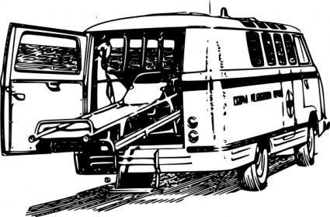 DIAL 911

Non-Emergency Contacts
Hospitals
Pocono Medical 570-421-4000
Easton 610-250-4002
Palmerton 610-377-1300
St. Lukes 484-526-4000
(Allentown or Monroe Campus)
Lehigh Valley 610-991-3811

Ambulance
West End 610-681-5810
Wind Gap 610-863-7623

Fire Companies
Polk 570-620-1770
Saylorsburg 570- 421-2323
West End (rt. 115) 570-620-9409
West End (rt. 715) 570-992-6118

Police
Fern Ridge 570-646-2271

Saylorsburg Playground Field
1504 Bonser Rd, Saylorsburg, PA 18353
Ball Field 911 Addresses
Cornerstone Community Church Field
388 Polk Township Rd, Kunkletown, PA 18058

Effort Fields
963 Gilbert Rd, Effort, PA 18330

Eldred Field
516 Kunkletown Rd, Kunkletown, PA 18058

Gilbert Field
West End Fairgrounds
570 Fairgrounds Rd, Gilbert, PA 18331

Jaycee Fields
1052 Molasses Valley Rd, Kunkletown, PA 18058

Kunkletown Field
124 Grove Rd, Kunkletown, PA 18058

Pleasant Valley Elementary School Fields
476 Polk Township Road, Kunkletown, PA 18058

Pleasant Valley Presbyterian Church Fields
150 Pilgrim Way, Brodheadsville, PA 18322

DIAL 911 FOR ALL EMERGENCIES

West End Little League Code of Conduct & Standards

- Zero tolerance policy regarding alcohol & tobacco. There is positively no alcohol consumption or tobacco use (smoking, smokeless, chew, snuff, or vaping) allowed anywhere within/during any WELL functions. This includes, but is not limited to, dugouts, bleachers, fields, woods, playgrounds, parking lots, and outside of your vehicle.
- No profanity will be tolerated.
- No one should ever speak disrespectfully to any manager, coach, umpire, player or spectator. Your signed code of conduct will be enforced.
- No teams shall practice or take the field at any time unless a league approved Manager and/or Coach is present.
- Only League APPROVED managers, coaches, players and umpires are allowed on the playing field or in/around the dugouts. No parents, siblings, volunteer score keepers, or pitch counters are allowed in/around dugouts.
- All players not actively engaged on the field during a game must remain in the dugout area.
- No swinging bats or throwing balls in any spectator area or parking lot of any WELL function.
- Catchers must use/wear full gear. This includes while warming up with a pitcher, and in batting practice sessions. Full gear includes: Face mask helmet with dangling throat guard, chest protector, shin guards, & safety cup.
- Pitching “L” screens are required at the Majors level for all batting practice. This includes practices and pre-game batting practice. If any damage occurs to the screens, please contact either the league Equipment Manager or the league Safety Officer.
- No throwing balls against any dugout, fence, or backstop.
- No throwing rocks.
- No climbing fences.
- Only a player on the field in an “at bat” position may swing a bat. There is no “on deck” batter in any age group of 5-12 BB or SB. * Note: for Majors BB 13-years and up, “on deck” batters are allowed
- Players and spectators should always be alert for foul balls and errant throws.
- All gates to the fields and playing areas must be kept closed. After players enter/leave playing fields, gates should be properly closed and secured.
- After each game, each team is expected to clean up their dugout and spectator areas. Team areas are expected to be free of all trash, bottles, snacks, and such. Trash receptacles must be emptied after each game.
- Speed limit is 5 mph in driveways and parking lots while attending any WELL function.
Please watch for small children around parked cars.
- Use crosswalks when crossing any roadways.
- Children not on the field as a team member in any play area or attending any game, must be supervised by a responsible adult. At no time should a child be left unattended. Coaching staff cannot supervise any children other than those of their team
- No children should play in any parking area.
- No playing on any lawn equipment or around any sheds.
- No pets are allowed on or in any WELL function or property.
- Failure to comply with the League Code of Conduct & Standards, the Manager & Coach Code of Conduct, or the Parent Code of Conduct may result in expulsion from the West End Little League field or function as well as future events or games.

Concession Stand Safety

Food Handlers
- Food handlers should thoroughly wash hands for 30 seconds with soap and warm water after potential contamination events.
- Potential contamination events include going to the bathroom, sneezing or coughing, touching face, eating or taking a break, touching contaminated surfaces or utensils, touching uncooked meat, touching cash register, answering phone, dumping the garbage, touching pets, changing diapers, etc.
- Gloves are recommended as an additional barrier but don’t take the place of frequent hand washings. Gloves should be changed at every hand washing and when they are soiled or contaminated.
- Use of hand sanitizers can supplement hand washings.
- Food handlers must not have symptoms of disease (coughing, sneezing, sniffling, fever, nausea, vomiting, diarrhea, etc.) or open wounds when handling food.
- Proper clothing includes clean outer garments and hats / hairnets.
- Food handlers should not touch ready to eat foods with bare hands and should instead use an appropriate utensil, gloves, or deli paper.
- Always use a scooper instead of bare hands to dispense ice for drinks.

Insects And Vermin
- Insects and vermin such as flies, cockroaches, rats, and mice can transmit disease when they come in contact with food.
- Flies that land in feces and then land on food can also transmit disease even though this is not common.
- All food should be stored off the floor.
- All unused food should be disposed of both during the event and after the event to eliminate unwanted pests.
- Food preparation surfaces should be constantly cleaned and wiped down to discourage insects.
- Keep food covered to protect against insects.
- Keep a tight lid on the trash to keep out insects.
- Dispose of wastewater in an approved method instead of dumping outside the concession stand.
- Store pesticides away from foods.

Refrigeration and Freezing
- Foods that require refrigeration must be cooled and held to 40 degrees F or lower until ready to serve.
- Use a thermometer in your refrigerator and freezer and make sure that your freezer runs at 40 degrees F and your freezer at 0 degrees F.
- Quick cooling involves the use of an ice bath (60% ice, 40% water) or the use of shallow refrigeration trays no more than 4 inches in depth.
- Always marinate meat, poultry, and fish in a refrigerator and not on a counter.
- Always thaw food in the refrigerator or microwave prior to cooking. Otherwise, the outer layers are subject to bacterial growth before the inside thaws.
- Freeze fresh meat, poultry, or fish immediately if you can’t use it within a few days.
- Never leave perishable food out of the refrigerator for more than two hours.

Cooking to Proper Temperatures
- All potentially hazardous foods should be properly cooked and held at an internal temperature of 140 degrees F and above.
- USDA cooking temperature recommendations: ground beef, pork, and egg dishes (160 degrees F), poultry (165 degrees F), and steaks, roast, beef, veal, lamb, chops, and fish (145 degrees F)
- When cooking meat, you can’t rely on the color of the meat as an accurate gauge of temperature.
- Always use an “instant read” food thermometer to determine the temperature of foods for cooking and holding temperatures. When cooking, use the thermometer in thickest part of meat. Be sure to wash the thermometer with hot, soapy water between uses.
- Never partially pre cook meat, poultry, and fish and then wait until final grilling. Instead, always immediately grill after pre cooking
- If meats and poultry are completely cooked ahead of time and then chilled, it's OK to put them on grill for reheating.

Microwave Cooking Instructions
- Microwaves often leave cold spots in hazardous foods where bacteria can survive.
- Cover hazardous foods with a lid or plastic wrap so that steam can be retained to assist in cooking.
- Stir and rotate for even cooking.
- Always observe the standing time on microwave directions as food finishes cooking during this time.
- Use an “instant read” food thermometer and make sure food is heated appropriately to USDA recommendations.

Reheating
- Quickly reheat potentially hazardous foods to 165 degrees F.
- Avoid using show cook devices such as crock pots or steam tables as they may activate bacteria and may never reach 165 degrees F.

Use Disposable Containers, Utensils, Napkins
- Disposable knives, forks, spoons, plates, and napkins should be used to cut down on cleaning and contamination.
- Disposable products should not be cleaned and reused.

Cleaning and Sanitation
- Always use plastic cutting boards instead of wood cutting boards, as wood cutting boards tend to hold bacteria.
- Use disposable utensils for food service whenever possible.
- When washing pots, platters, containers, utensils, etc. always use the four-stage process of washing in hot soapy water, rinsing in clean water, chemical or heat sanitizing, and air-drying.
- Frequently sanitize and wipe down all food preparation surfaces, refrigerators, freezers, coolers, and other concession equipment.
- Wiping cloths should be stored in chemical solution buckets with an appropriate ratio of bleach to water such as 1/2 teaspoon to one gallon of water.
- Frequently wash and replace all sponges, towels, wiping cloths.
- Frequently dump garbage and sweep or vacuum floors.

Separating
- Never use unclean food preparation utensils for serving food.
- Place raw meat, poultry, or fish on a plate before refrigerating to make sure that juices don’t leak and contaminate other food.
- Never commingle ice to cool drinks with ice to be served.

Parent Code of Conduct
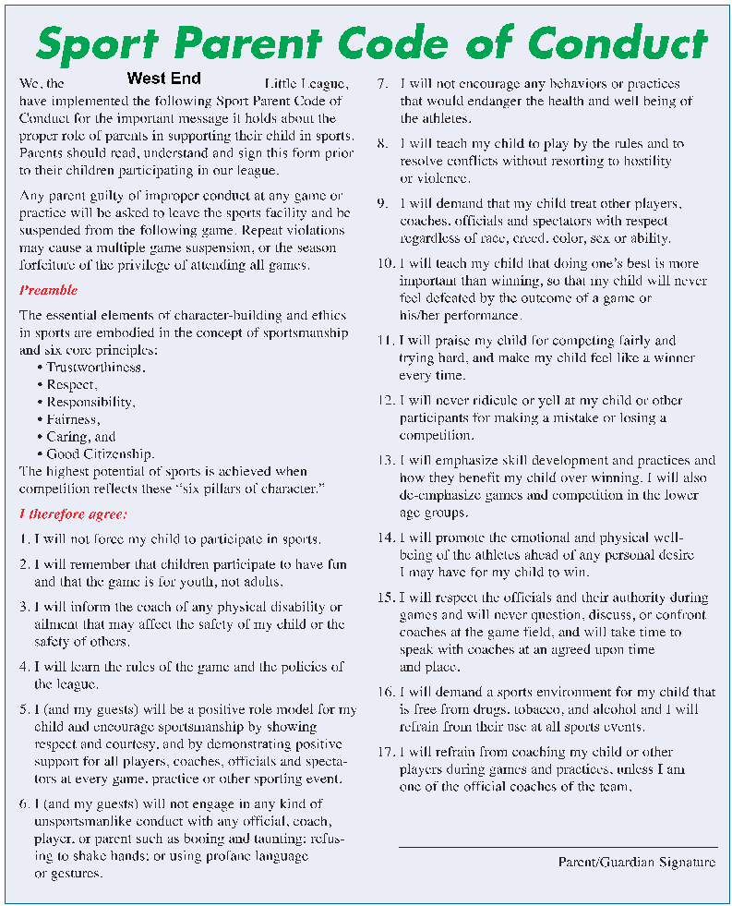

Manager and Coach Code of Conduct

“Next year it won’t matter who struck out, who dropped a fly ball, who hit a home run or how many wins and losses your Little League team had. But the world will be a better place if you make a difference in a child’s life.”

I, the undersigned, do hereby agree that being appointed a West End Little League Manager or Coach, requires that I conduct myself in a most respectful and positive matter. I understand that as manager/coach I am a role model for my players as well as my opponent’s players.

I will at all times be fair and respectful to all of the PLAYERS, PARENTS, UMPIRES, MEMBERS OF THE LEAGUE and fellow managers/coaches.

As a manager/coach I will read and understand the current season rule book so that I may have a better understanding and knowledge of Little League rules, thus allowing me to teach all players the correct rules of the game.

I understand that if I should lose my temper causing me to yell or act in a negative matter toward any player, parent, umpires, members of league and fellow managers and coaches, I shall be immediately suspended from the next game. If I should repeat the offense, I shall be asked to present myself before the Board of Directors at which time a hearing will take place to determine the next course of action. I also understand that if I knowingly break any safety regulation I will be given a warning for the first offense, if there is a second offense I will be called before the Board of Directors to determine the next course of action.

I understand that as manager/coach I am expected to treat every child with dignity and respect. I
am a teacher of the sport of softball/baseball.

I understand that as manager/coach the rewards I will receive will be in the eyes of the players and NOT in the number of games won.

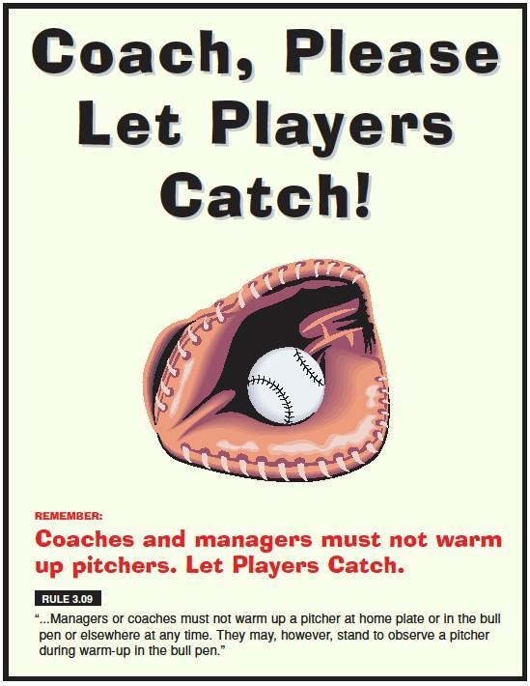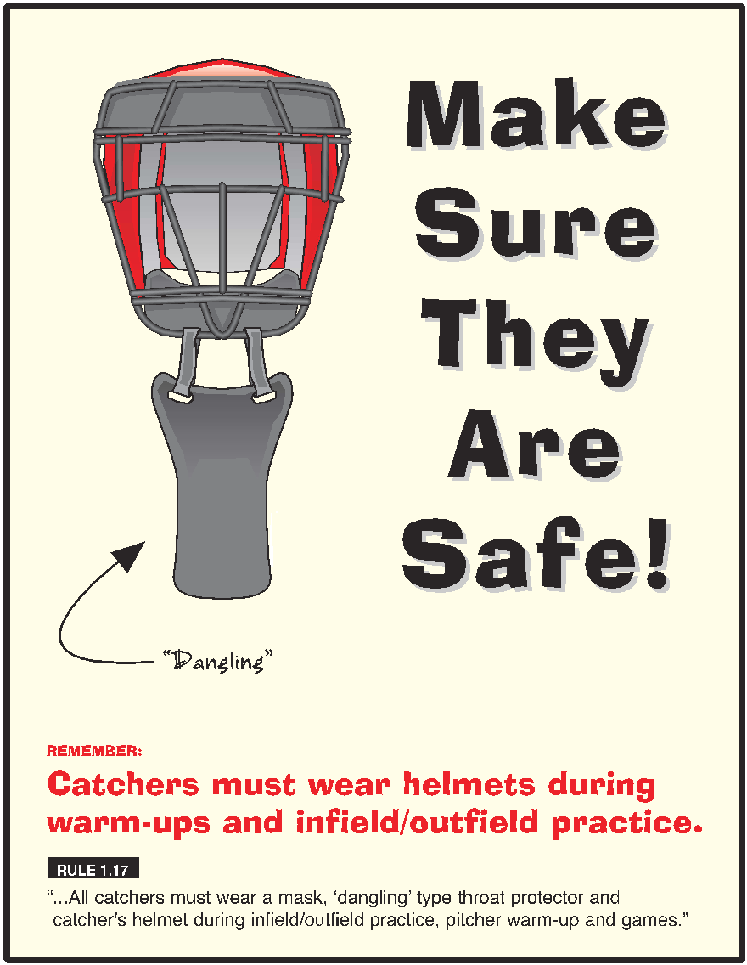

West End Little League Manager Responsibilities

Managers for the current season must be recommended by the division player representative, nominated by the President for board approval, and approved by the board of directors with a majority in-favor vote. Managers are directly responsible for the team and the coach’s actions on the playing field. Managers represent the team in all communications with the umpire and the opposing team.

Managers have the following responsibilities:

- Attend the Safety/Fundamentals Training.
- Successfully complete Heads-Up Concussion Training & submit your certificate to the League Safety Officer.
- A manager is responsible for the team’s conduct. Follow and enforce all official rules. Give deference to the umpire.
- A manager is responsible for the safety of his/her players, coaches, and spectators.
- A manager is responsible for the actions of his/her assistant coaches.
- The manager shall act as liaison between the player agent/rep of their respective division, coaches, and parents, keeping everyone informed of pertinent information and dates.
- The manager will have in his/her possession at every WELL function, game, & practice, his/her Safety manual, first aid kit, and league supplied equipment. If any manager is unable to attend a practice or game, it is his/her responsibility to see that the assistant coach has the above items.
- The board of directors highly encourages all managers to attend at least 6 league meetings per year.
- The board of directors highly encourages all managers to view the WELL training video library available at the Western Pocono Community Library, located in Brodheadsville.

Storage Shed Procedures
The following applies to all storage sheds used by the West End Little League, and anyone who has been issued keys/codes to access and use these sheds.

All individuals with access to the WELL sheds should be aware of their responsibilities for the orderly, safe, storage of rakes, shovels, bases, chemicals, lime, etc. If you are not sure, contact the equipment manager for further information.

Storage sheds MUST be kept locked, this includes during games when you will be less likely to supervise the activities around the shed.

Make sure you are properly instructed on how to use any machinery (e.g., mowers, weed whackers, pitching machines, etc.) before use. No minors should operate any machine/equipment for any reason. A minor is anyone aged 16 years and under.

All chemicals should be stored in their proper, original containers, and correctly labeled. Any loose chemicals should be cleaned up immediately and disposed of properly. All chemicals should be used in well ventilated areas.

All items in sheds should be returned immediately when not being used.

West End Little League Coach Responsibilities

Coaches must adhere to all rules of Little League and the By-Laws that govern the West End Little League without exception.

Coaches for the current season must be recommended by the division player representative, nominated by the President for board approval, and approved by the board of directors with a majority in-favor vote.

The responsibilities of a coach are numerous. To be a successful coach, you must follow these responsibilities. These responsibilities include, but are not limited to, the following:

- Attend the Safety/Fundamentals Training.
- Successfully complete Heads-Up Concussion Training & submit your certificate to the League Safety Officer.
- Understand and communicate effectively with the age group that you are coaching.
- Set an example of respect for your players by displaying proper conduct in dealing with opposing coaches, umpires, and parents.
- Refrain from confrontations, both on and off the field.
- Demonstrate mutual respect for everyone.
- Do not argue, discuss, or criticize any judgment calls by the umpire; any perceived incorrect rule call should be discussed privately between the Manager and Umpire; however, the decision of the umpire is final.
- Account for all uniforms and equipment (to include first aid kit). All equipment must be collected and returned at the end of season.
- Account for each player on your team, and those present at each event or game. Know where your players are. Be sure each player secures a way home with their parent or guardian before you leave the field. Never leave a player unattended on a field for any reason.
- Report to their player rep as required and stated by each rep prior to season start. This includes, but is not limited to reporting game statistics, pitching counts, etc.
- The board of directors highly encourages all coaches to attend at least 6 league meetings per year.
- The board of directors highly encourages all coaches to view the WELL training video library available at the Western Pocono Community Library, located in Brodheadsville.
- Teach your players how to play by conveying your knowledge to them. Instill in your players the desire to improve their skills and how to win. Teach your players respect and to display good sportsmanship in winning and losing. Coaching is teaching.
- Make each season challenging and fun. Provide a learning experience for each child. The true measure of your coaching abilities is not the number of wins and losses, but the positive impact you have on your players’ development.

Information on Concussions
All Managers, Coaches, Umpires, and Team Parents/Helpers must successfully complete the Center for Disease Control Heads-Up Concussion Training. This training is free and is available online via the following link: https://headsup.cdc.gov/

Before you are permitted to take the field for any game or practice, you must provide the Board of Directors with your completion certificate. Upon completion of your training, provide a copy of your certificate to the league Safety Officer. Additional information about the training can be found here: https://www.cdc.gov/headsup/youthsports/

The following Little League regulation applies to all divisions:
Regulation III(d)(2) Note 3:
NOTE 3:
If a medical professional, Umpire in Chief, the player’s coach, the player’s manager, or the player’s parent has determined a player sustains a possible concussion, the player must be, at a minimum, removed from the game and/or practice for the remainder of that day. The league must also be aware of its respective state/provincial/municipal laws with regards to concussions and impose any additional requirements as necessary. His/ her return to full participation is subject to 1.) the league’s adherence to its respective state/provincial/municipal laws, 2.) an evaluation and a written clearance from a physician or other accredited medical provider and 3.) written acknowledgment of the parents.

Little League International strongly encourages all leagues and teams to not only comply with any applicable state/provincial/municipal laws, but also, to review the information and training materials on concussions that are available free of charge on the Centers For Disease Control website, accessible at LittleLeague.org/concussions. This link also provides concussion information from all 50 states.

Pennsylvania State Law

The Safety in Youth Sports Act was passed and signed into law in 2011 (P.L. 411, No. 101). This law requires that the Department of Health and the Department of Education develop guidelines and materials on concussions. Each year, a student participating in an athletic activity must have a parent/guardian sign an acknowledgement of receipt of this information before the student may participate in the activity. The law requires that any student suspected of sustaining a concussion must be removed from participation at that time. The student is not allowed to resume participation until evaluated by a medical professional and given written clearance. The law also requires that coaches receive concussion training once each school year.

The sponsors of youth athletic activities not addressed by this act are encouraged to follow the guidance set forth in the act.

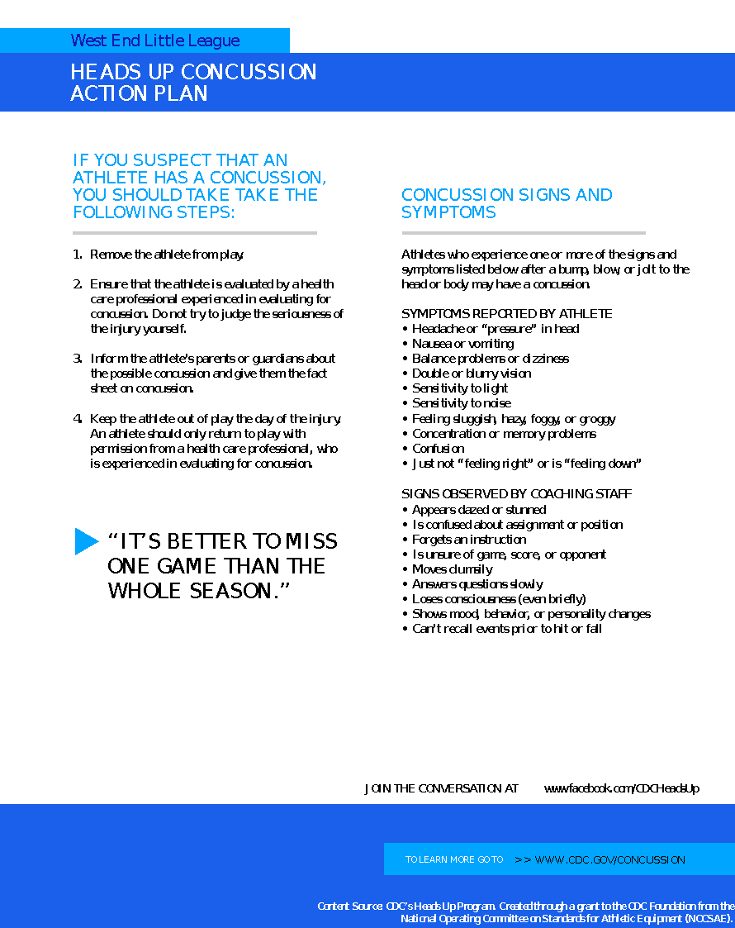

Safety Inspection
Regular safety inspections of the field, permanent and temporary structures, ball playing equipment, and personal protective equipment is the best way to determine which unsafe conditions require correction. The coaching staff and parents should work together to insure serious accident exposures are corrected promptly. It is a good experience and good safety training to have your players take part in this process.

The following list will assist you in identifying conditions that cause accidents. Prompt attention and action must be taken to correct all serious hazards. Look for:

- Unsafe field conditions such as holes, ditches, rough or uneven spots, slippery areas and long grass
- Foreign objects like stones, broken glass, old boards, bottles, rakes, etc.
- Incomplete or defective screen or fencing, including holes, and sharp or loose edges. Wire and link fencing should be checked regularly for defects to prevent injury to players.
- Forty feet in the center section of outfield fence should be painted a dark color and kept free of signs to provide contrast with balls thrown toward home.
- The warning track, if provided, should be well defined and not less than 10 feet wide.
- The backstop should be padded and painted a dark color for the safety of the catcher.
- The dugout should be free and clear of all debris, with equipment stored properly and off the ground.
- Home plate, bases, and the pitcher’s rubber should be checked for tripping and stumbling hazards
- Material used for marking the field should be non-irritating white pigment and not lime
- Pay constant attention to the possible lack of, or poor fit of, personal protective equipment (e.g., helmets, mask, catchers gear, shoes). Plastic support cups and supporters are required for all catchers, and players.
- The league recommends that corrective glasses be of the sport safety type; sunglasses should be of a shatterproof non-mirrored type.
- Bats should be free of cracks or dents, and have secure grips. Damaged bats should be removed immediately.
- Safety should be the main factor in cancelling a game or practice due to bad weather or darkness.
- The correct fitting and neat appearance of uniforms has the indirect benefit of contributing to pride, morale, and discipline, which stimulates our main safety objective of greater skill for fewer accidents.

The greatest (although least frequent) hazard in connection with the weather is exposure to lightning. Chances of surviving a lightning strike are so slight that managers and umpires must not take any chances on continuing practice or games when an electrical storm is approaching. At the first indication of such a storm, everyone MUST leave the playing fields and dugouts and return to a car or inside a building.

Safety Code / Tips

• All Adult Members of West End Little League (Managers, Coaches, Umpires, Team Parents) are responsible to ensure that all safety procedures are followed.
• Managers, coaches, and umpires should have some knowledge and training in basic first aid. You must have a first aid kit should available during practices and games – this is part of your equipment!
• No games or practices should be held when weather or field conditions are not safe, particularly when lighting is inadequate.
• Play areas should be inspected and free of holes, damage, glass, debris, or other objects considered unsafe to playing conditions; use your best judgment for the safety of your players.
• Dugouts, bat racks, and helmet bags should be placed behind a fence or adequate screen.
• During practice and games, all players must remain alert and watch the batter.
• During warm up drills, players should be spaced so that no one is endangered by errant balls.
• Equipment should be inspected daily. All equipment must fit properly!
• Pitching machines, if used, must be in good working order (including extension cords) and must only be operated by adult coaching staff.
• Headfirst slides are not permitted, except when returning to a base, for ages 5-12 BB and SB.
• Break-away bases should be used on all fields.
• At no time should “horse play” be permitted on playing fields or in dugouts.
• No jewelry of any type is allowed in any division (exception: medical id alert).
• Helmets and catcher’s masks should not be painted or have any stickers, tags, or markings, other than that of manufacturer.
• Players who have been injured, ejected, or otherwise removed from game shall remain under supervision until released to parent or guardian.

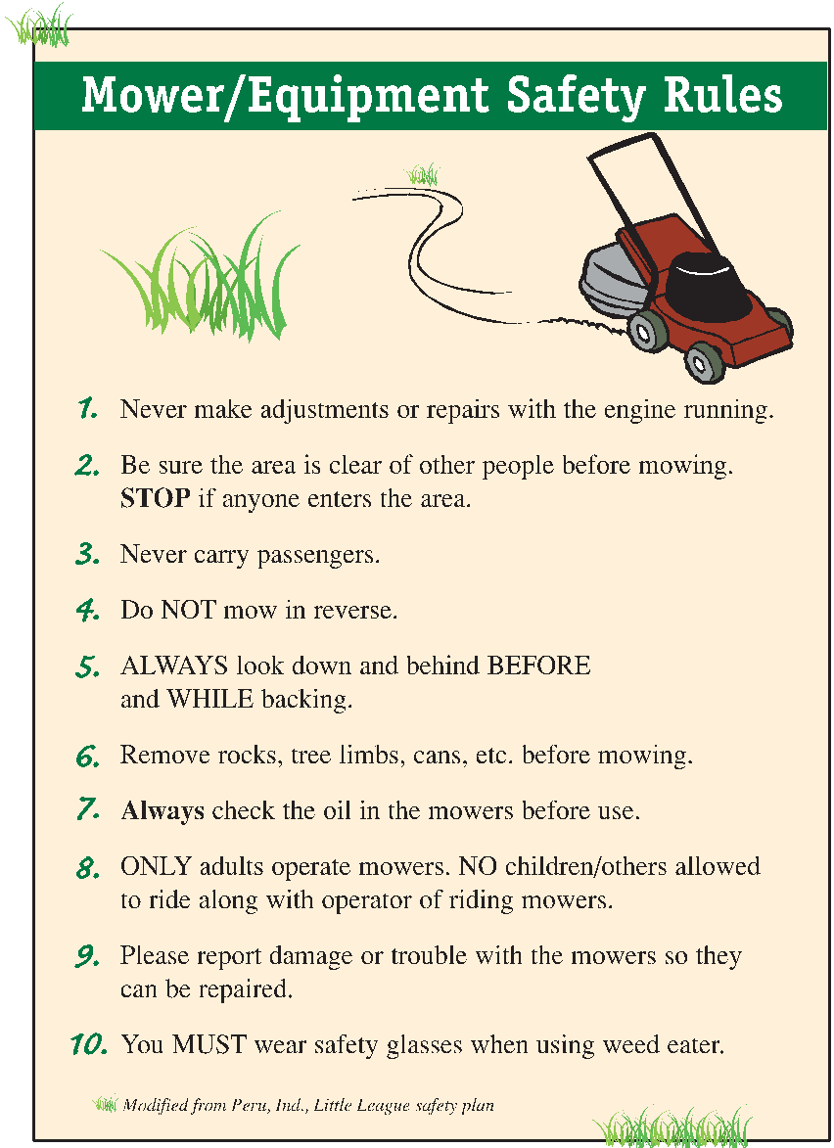
SAFETY FIRST /USE YOUR HEAD

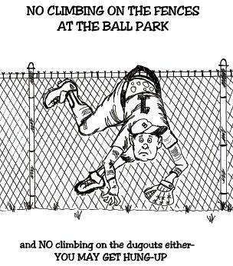

First Aid Tips

Good Samaritan Laws: these laws were developed to encourage people to help others during an emergency situation. These laws require that you use common sense and a reasonable level of skill not to exceed the scope of your training in emergency situations…

These laws are to protect you when you help someone in a medical emergency. They give legal protection to those who provide emergency care to an injured person, providing you respond and act as a reasonable and prudent person.

For Example:
• Move a victim only if the victim’s life is in danger
• Ask a conscious victim for permission before providing any care
• Check the victim for life threatening emergencies before providing further care
• Summon professional help to the scene by calling 911
• Continue to provide care until more highly trained personal arrive

Heat Disorders:

Fluid Retention: Frequent fluid replacement before, during, and after exercise can help prevent the body from overheating. Be aware of the three (3) most common heat disorders by learning to recognize their symptoms.
Before: Drink 8 oz. immediately before exercise.
During: Drink at least 4 oz. every 20 minutes.
After: Drink 16 oz. for every pound of weight lost during activity.

Heat cramps: Sudden painful muscle contractions often caused by acute loss of body fluids and mineral depletion through sweating or the result of an acute blow
Actions: Athlete’s should massage and gently stretch muscles, replace fluids, rest

Heat Exhaustion: Weakness, dizziness, profuse sweating, and rapid pulse
Actions: Rest athlete in shade with legs elevated. Replenish fluids, call for emergency medical help and transport

Heat Stroke: High body temperature red hot dry skin, also a rapid pulse, difficulty breathing collapse and convulsions.
Actions: This is a MEDICAL EMERGENCY AND MAY BE FATAL, seconds count! CALL immediately for emergency response and medical care. Place athlete in shade cool body if possible to lower body temperature while waiting for medical help

Musculoskeletal Injuries:

Strains and Sprains: Muscle strains and sprains are common in athletics, symptoms usually include pain, limited motion, swelling, and possibly skin discoloration
Actions: Call for emergency transport. While waiting, carefully compress ice to the injured area and elevate it above the level of heart (if possible) to reduce swelling.

Discoloration and Fractures: while not always evident the common symptoms are pain, deformed joint and loss of function
Actions: Obtain emergency care immediately, DO NOT attempt to move athlete

MINOR TREATMENT OF INJURED PLAYERS

- A bleeding player should be removed from game as quickly as possible
- Bleeding must be stopped and the open wound covered.
- The uniform must be changed if any sign of blood is on it or visible before the player may return to game
- Routinely change gloves to prevent exposure when in contact with any blood or bodily fluid
- Immediately wash hands and other skin surfaces if contaminated with blood
- Follow acceptable guidelines to control bleeding and dispose of all materials that come in contact with the wound.
PRESCRIPTION MEDICATION

Do not at any time administer any kind of prescription medication or over the counter medication. THIS IS THE PARENT/GUARDIAN RESPONSIBILITY only.
This includes prescribed, over counter & inhalers … No Exceptions…

ASTHMA AND ALLERGIES

• A child with asthma needs to be watched. If a child starts to have an asthma attack have him stop playing immediately and calm down until breathing is normal.
• Allergy symptoms can manifest themselves to look like a cold; it can make breathing difficult especially with someone who has asthma.
• Use common sense and listen to the child’s breathing if he or she is struggling then it should be addressed accordingly

IF EVER IN DOUBT CALL 911 IMMEDIALTY FOR EMERGENCY RESPONSE

Red Cross First Aid Tips
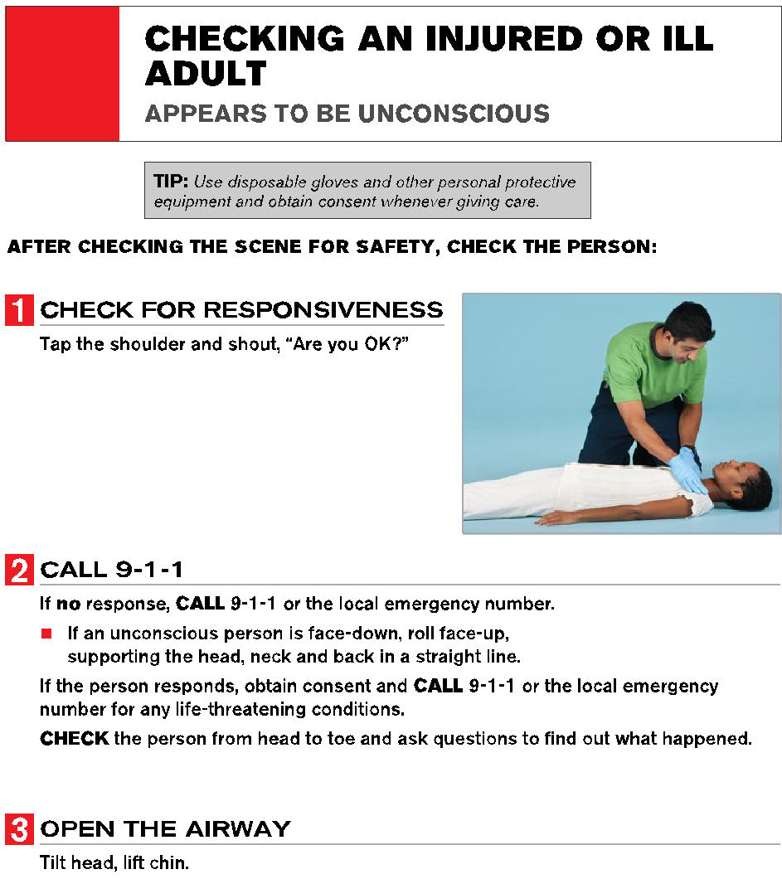

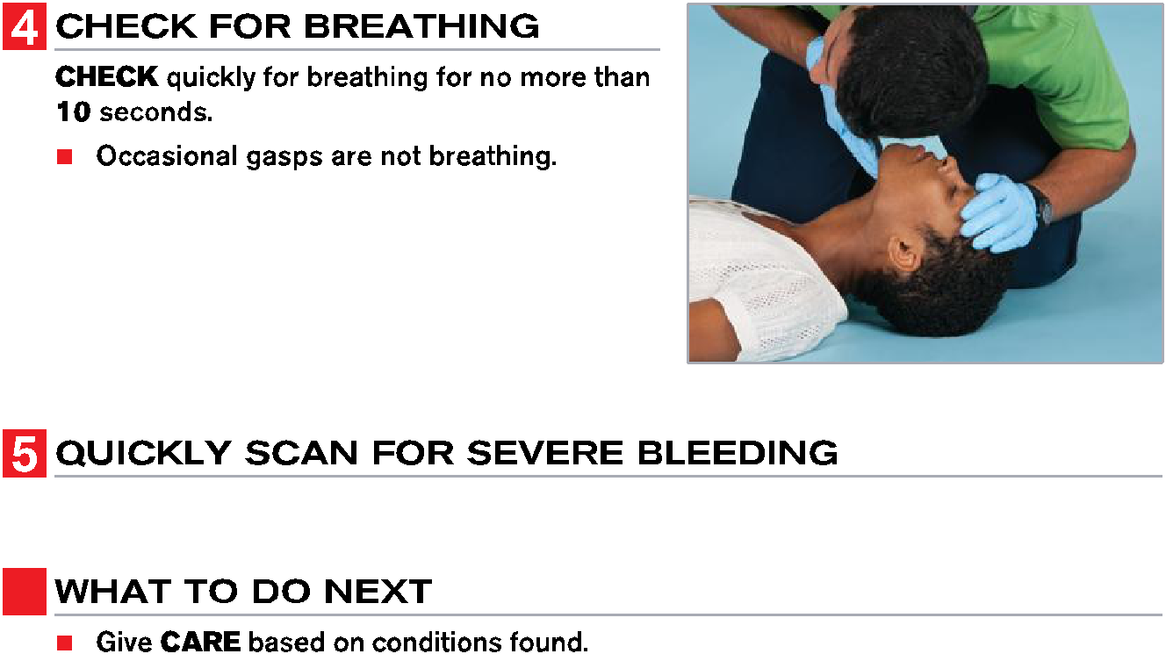
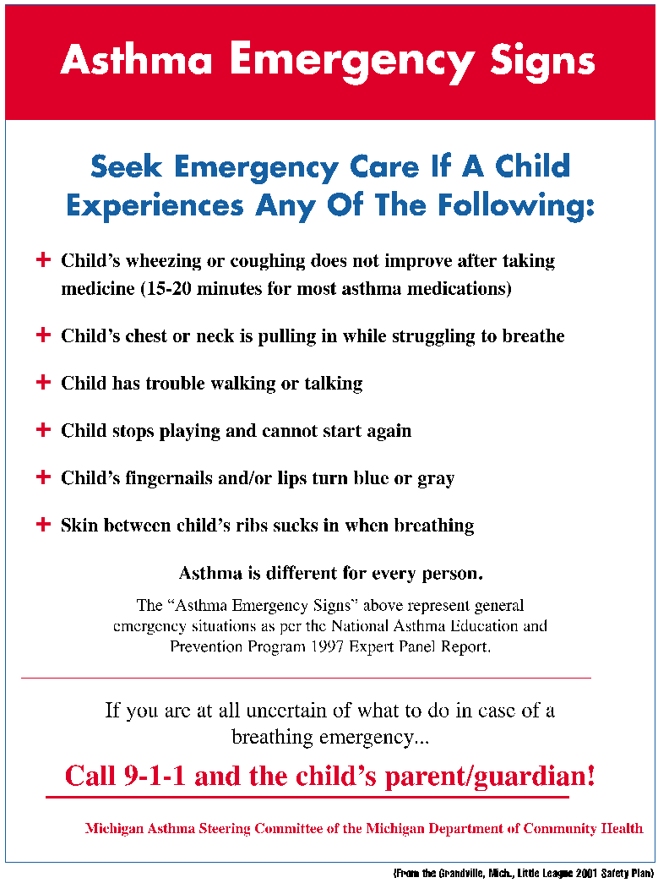

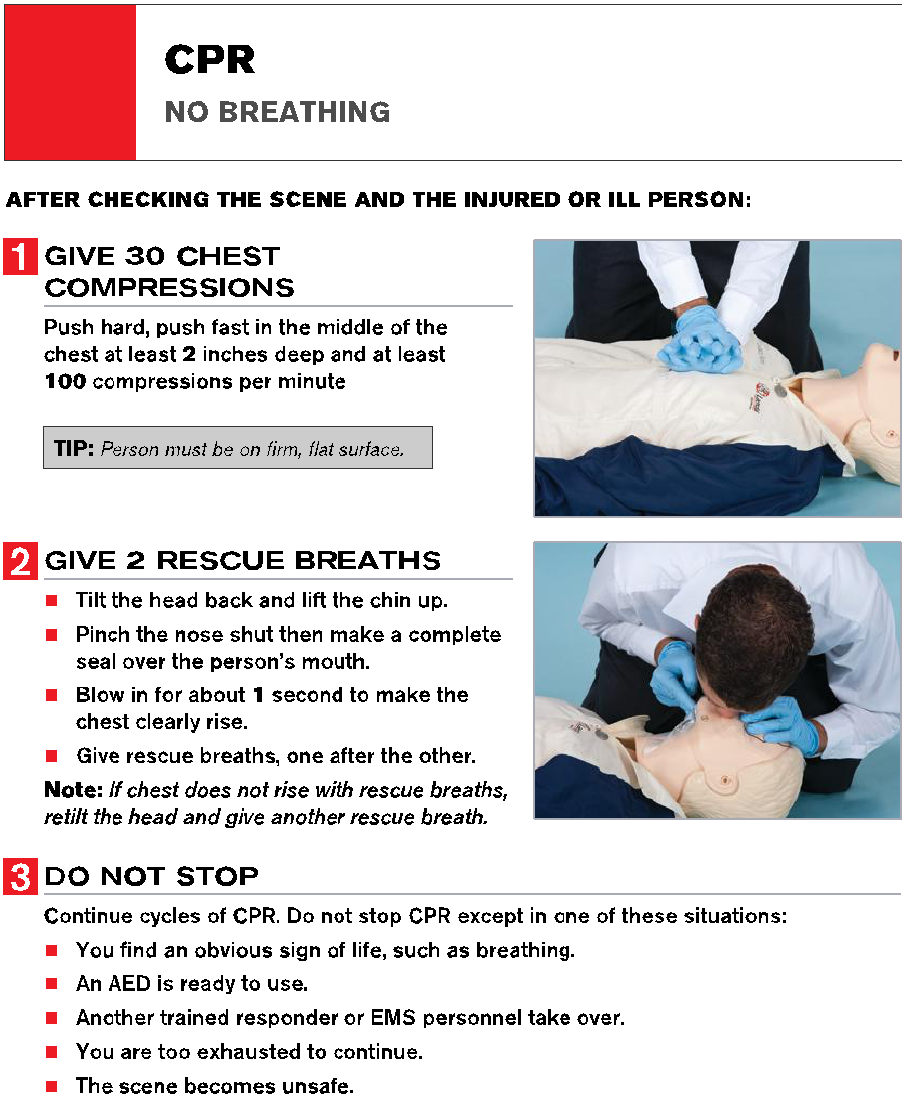

Accident Reporting Procedures

What to report:
Any accident that causes any player, manager, coach, umpire or volunteer to receive medical treatment and or first aid must be reported to the Safety officer (and the player rep of division for follow up) This includes even passive treatments such as evaluations and diagnosis of the extent of the injury.

When to report:
All such incidents described must be reported within 24 hours.

How to report:
Have the parent/adult complete the Accident Notification Form as soon as possible (at the site, if possible). Hand deliver or scan/email the Accident Notification Form to the Safety Officer and Player Rep.

Call or email the safety officer and player rep, and have the following information;
• Name and phone number of the individual involved
• Parents or guardians name and number if injured is a minor
• Date, time and location of incident
• A detailed description of the incident as possible
• Name, phone number and relationship to the injured of the person reporting the injury
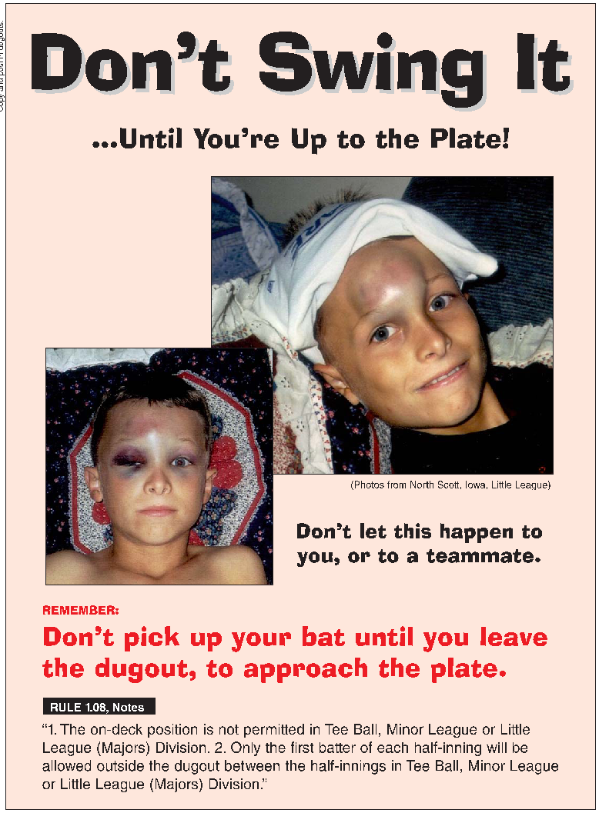

NO INJURED PLAYER CAN RETURN TO HIS/HER TEAM WITHOUT A RELEASE LETTER OR NOTE FROM THE DOCTOR WHO IS OR HAS TREATED THEM FOR REPORTED INJURY

A COPY OF THIS RELEASE SHOULD BE GIVEN TO THE SAFETY OFFICER AND THE PLAYER REP IN A TIMELY MATTER

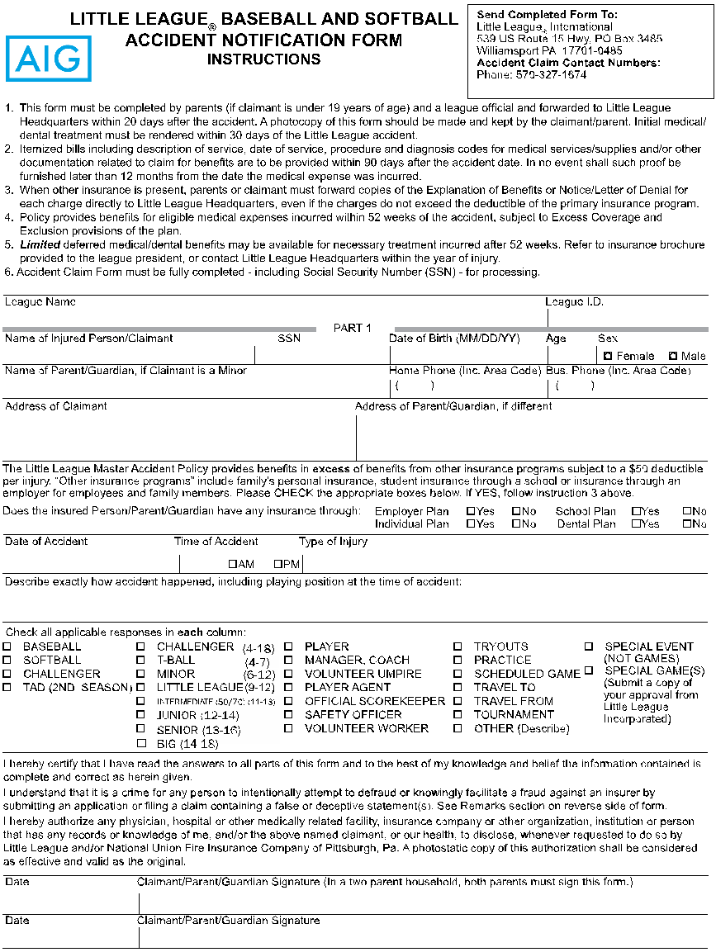
Accident Notification Form & Instructions

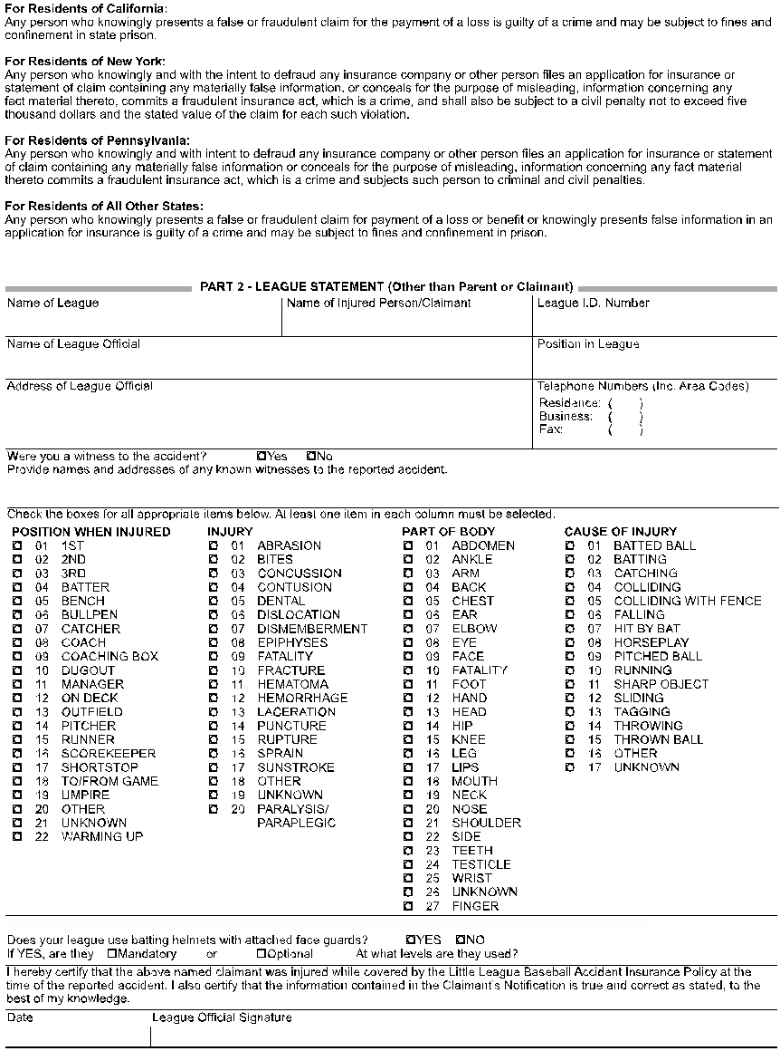

Communicable Disease Procedures
While risk of one athlete infecting another with HIV/AIDS during competition is close to non-existent, there is a remote risk that other blood born infectious diseases can be transmitted. For example, Hepatitis B can be present in blood as well as in other body fluids. Procedures for reducing the potential for transmission of these infectious agents should include, but not be limited to, the following:
1. The bleeding must be stopped, the open wound covered, and if there is an excessive amount of blood on the uniform, it must be changed before the athlete may participate.
2. Routine use of gloves or other precautions to prevent skin and mucous-membrane exposure when contact with blood or other body fluids is anticipated.
3. Immediately wash hands and other skin surfaces if contaminated (in contact) with blood or other body fluids. Wash hands immediately after removing gloves.
4. Clean all contaminated surfaces and equipment with an appropriate disinfectant before competition resumes.
5. Practice proper disposal procedures to prevent injuries caused by needles, scalpels, and other sharp instruments or devices.
6. Although saliva has not been implicated in HIV transmission, to minimize the need for emergency mouth-to-mouth resuscitation, mouthpieces, resuscitation bags, or other ventilation devices should be available for use.
7. Athletic trainers/coaches with bleeding or oozing skin conditions should refrain from all direct athletic care until the condition resolves.
8. Contaminated towels should be properly disposed of/disinfected.
9. Follow acceptable guidelines in the immediate control of bleeding, and when handling bloody dressings, mouth guards, and other articles containing body fluids.
Additional information is available from your state high school association and from the National Federation TARGET program.

Dental Injuries
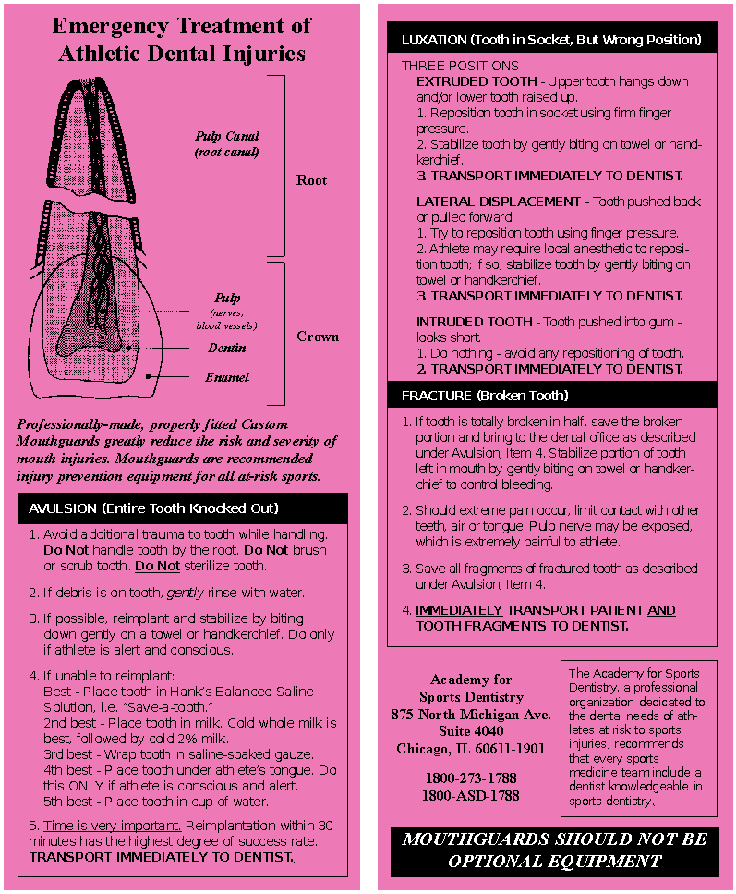

Weather Safety
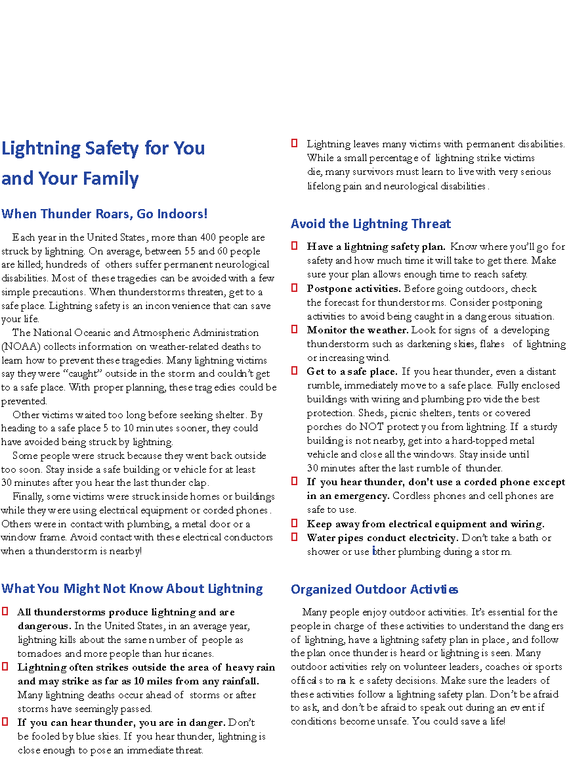
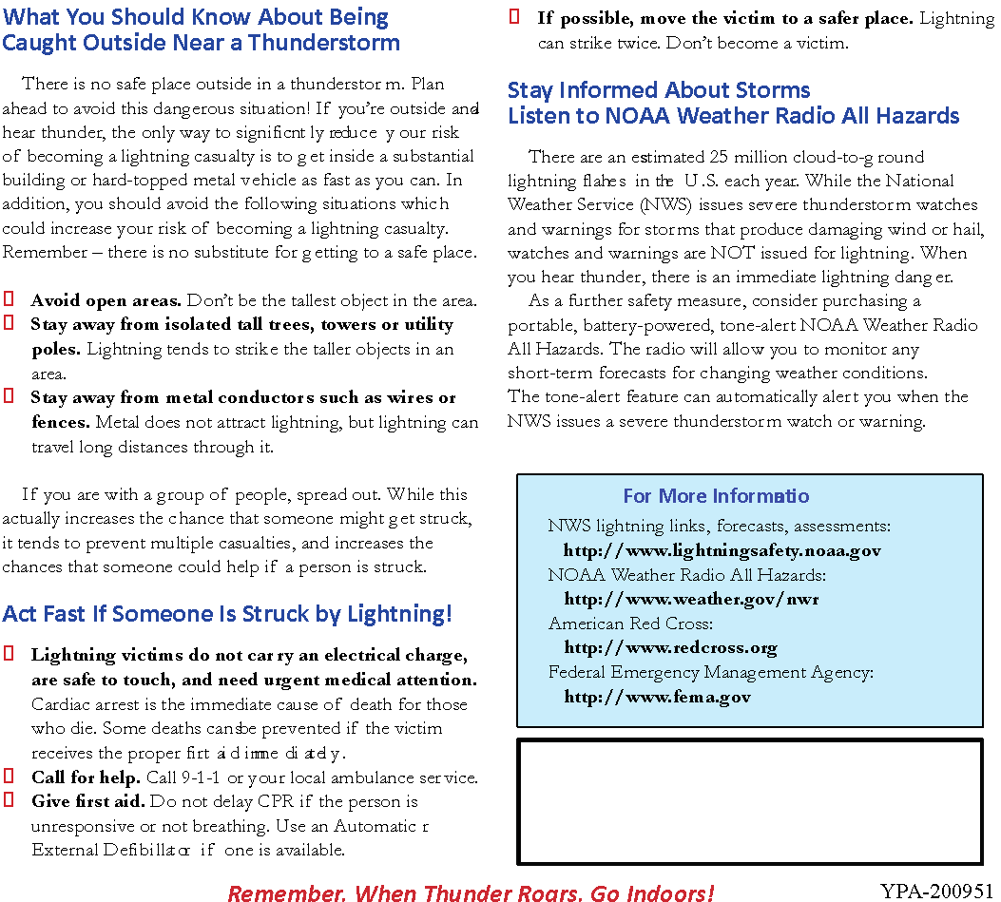

Child Protection Program and Volunteer Application Form
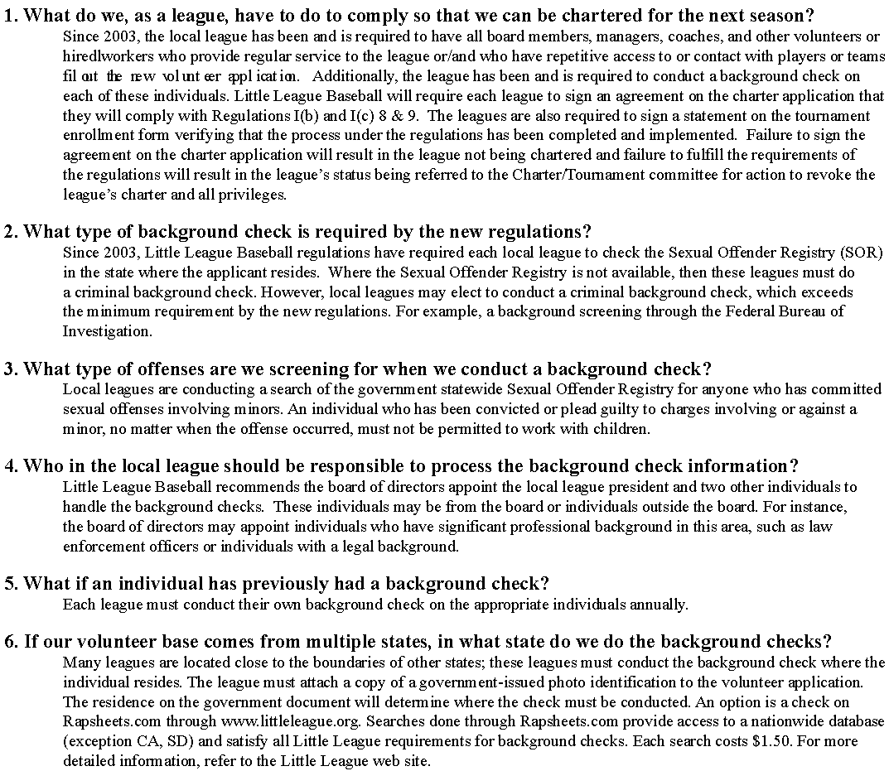

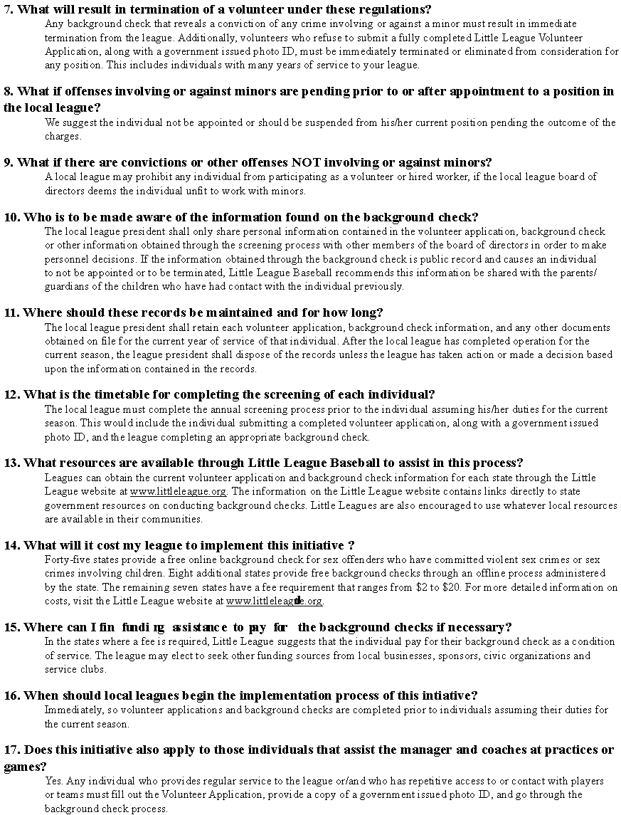
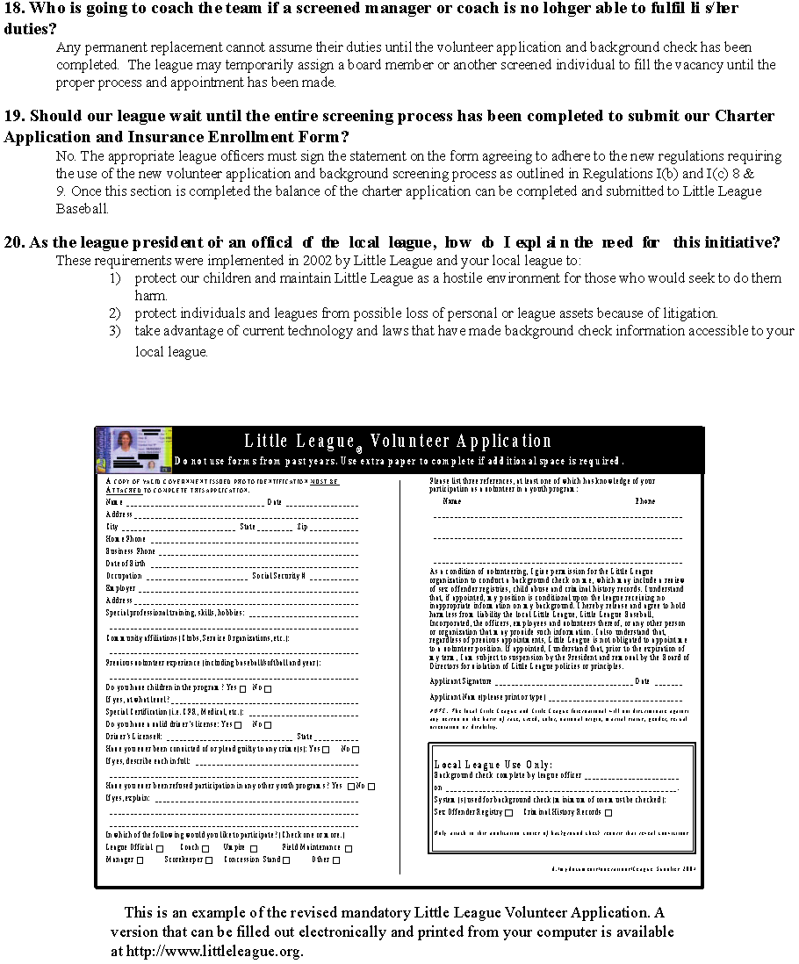

Tips, Drills, & Information for Coaches
Some Advice… Children should never be encouraged to “play through the pain”. Pain is a warning sign of injury. Ignoring it can lead to a greater injury. Use common sense. If a pitcher says his arm is hurting take him/her off the mound
Pre-Season
Take possession of this safety manual and the first aid kit with your equipment provided by the West End Little League.
Ask a parent to help out as your “unofficial safety officer”, with this duty they must agree to attend and be present at all practices and games as well as have access to a cell phone for emergencies.
Meet your parents pre-season and discuss WELL rules and expectations and our Safety policies. Review the parent code of conduct
Cover rules, regulations and safety policies with your players
Encourage players and parents to bring water bottles to practice and games
Encourage the use of “safe” sunglasses, sunscreen, and mouth guards, remind catchers they must wear a protective cup, encourage your male players to wear supporters
Season Play
Work closely with the Safety officer to make sure your equipment is in first rate working
order, if any equipment is questionable contact your league Equipment Manager.
• Do not expect more from your players than what players are capable of.
• Be more open to ideas and suggestions or help.
• Enforce that prevention is the key to reducing accidents to a minimum
• Use common sense
Pre-Game & Practices
• Make sure your players are healthy, rested, and alert.
• Make sure any returning, previously injured player has a medical release, signed by their Doctor. Otherwise, they cannot play. There is NO exception to this rule.
• Make sure the players are in full proper uniform and catchers are wearing a cup
• Agree with opposing manager on the fitness of playing field
• Have your team do proper stretching and warm up before you start any practice or game
During the Game
Make sure that the players carry gloves and other equipment off the field and go to the dugout when their team is at bat. No equipment should be left lying on field or in foul territory.
• Keep players alert
• Maintain discipline
• Be organized
• Keep players and subs sitting on the bench or in the dugout, unless participating in the game or preparing to enter the game
• No player should handle a bat at any time other than the “at bat” position
• Keep players hydrated
• Do not play children who are ill or injured
Pitching
- • Per Regulation VI, the manager must remove the pitcher when said pitcher reaches the limit for his/her age group as noted below. If a pitcher is removed, the may remain in the game at a different position:
League Age | Total Pitches
13 -16 | 95 pitches per day
11-12 | 85 pitches per day
9-10 | 75 pitches per day
7-8 | 50 pitches per day

Exception: If a pitcher reaches the limit imposed in Regulation VI(c) for his/her league age while facing a batter, the pitcher may continue to pitch until any one of the following conditions occurs:
- That batter reaches base;
- That batter is put out;
- The third out is made to complete the half-inning or the game.
NOTE: A pitcher who delivers 41 or more pitches in a game cannot play the position of catcher for the remainder of that day.
Post-Game
• Never leave the field until every team member has been picked up by a known family
member or guardian.
• Notify parents if their child has been injured, no matter how small
• Clean the dugouts and spectator areas of trash, rake fields, and lock all gates/ sheds
Errant Balls
The following will reduce the danger of being struck by a misdirected ball:
- All “unauthorized people” should remain off the field during drills
- One of the best preventive measures is to stress that all players keep their eye on the ball at all times.
- Another danger from a misdirected ball is the exposure of inexperienced batters to wild pitchers. The use of a batting helmet is mandatory. However, it does not justify permitting a potential pitcher throwing to an inexperienced batter until control is demonstrated.
- The danger of being struck by an errant ball can be further minimized by the following plan:
  - Throwing and catching drills should be set up with players in two lines facing each other
  - Random throwing should be permitted only to designated player
Safe Ball Handling
Misjudging the flight of a batted ball may be corrected by drilling with fly’s, which start easy and are made more difficult as a player’s ability, judgment, and skill improves. Everyone should be able to handle balls that go overhead. In addition to a player never losing sight of a ball from the time it leaves the bat, a player should keep the glove positioned and the body relaxed and ready for a split-second move to field the ball. An infielder can best be protected by an aggressive short hop fielding play by always keeping the nose pointed at the ball and eyes glued on it. Also, if moving forward, the player is in a better position to make a correct throw. It is safer for a player to knock down a ball and re-handle it then to let the ball determine the play.

Collisions
Collisions result in more injuries than is the case with most other types of accidents. They
are usually caused by errors of judgment or lack of team-work between fielders. It is important to establish zones of defense to avoid collisions between players. It is particularly important when players are chasing high fly balls. Once the zones are established, situation drills should be held until these zones and patterns become familiar to the players. The responsible player should call out the intentions in a loud voice to warn others away.
Here are some general rules to follow:
• The fielder at third base should catch all balls which are reachable and are hit between third and catcher
• The fielder at first base should catch all balls reachable which are hit between second and the catcher
• The short stop should call all balls reachable which are hit between second and third
• The fielder at second base should catch all balls reachable which are behind first base
• The shortstop has the responsibility for fly balls hit in the center of the diamond and in the area of second base. Since the glove is on the left hand, it is easier for the shortstop than the fielder at second to catch fly balls over second
• The centerfielder has the right of way in the outfield and should catch all balls which are reachable, another player should take the ball if it is seen that it is not reachable by the centerfielder
• Priorities are not easy to establish on ground balls but most managers expect their base player to field all ground balls they can reach cutting in front of the shortstop on slow hit grounders
• The catcher is expected to field all topped and bunted balls which can be reached except when there is a force play or squeeze play at home
Sliding Safety
As in the case with other baseball fundamentals, a correct slide is also a safe one. It is
important to guard against the accident of collision and the possibility of a player being struck by a thrown ball as that player “hit’s the dirt”.
The following can make the learning period safer:
• Long grass has been found to be better than a sand or sawdust pit to teach sliding
• The base should never be anchored down
• Sliding pads are recommended
• The player should make approaches at half speed and keep constantly in mind that hand and feet should be in air. Once committed to slide the player must follow through and not change the strategy. Last minute hesitation causes most sliding injuries
• If the ground along the base lines becomes soft on a rainy day, such weather offers an excellent opportunity to have sliding drills
• It should be kept in mind that headfirst sliding is not recommended or permitted in
LL ages 13 and under.
Batter Safety
A batter’s greatest accident exposure is from unsafe acts of others; namely wild pitches,
which account for a major portion of all accidents. This type of injury is more prevalent in regular than minor play.
• A well fitted LL approved helmet is required
• The development of the novice batter’s ability to take evasive action can be improved by getting the player to relax and concentrate on the ball from the time the pitcher starts delivery until it lands in the catcher’s mitt. Players with slow reflexes can also be helped by simulated batting and ducking practice with a tennis ball
• The unsportsmanlike practice of crowding the plate or jumping around to rattle the pitcher must not be tolerated. This could endanger the batter if it causes the pitcher to lose control.
• Making sure the batter holds the bat correctly while bunting can reduce painful finger and hand injuries. Youngsters tend to lean too far over the plate and not keep the ball well out toward the end of the bat.
• When the batter becomes a base runner, that player should be taught to run outside the foul lines when going from home plate to first and from third to home plate, to reduce the chance of being hit by a thrown ball.
Safe Bat Handling
A review of the batter’s potential for causing injuries to other’s points up the following;
• The most easily prevented type of accident is the too frequent fault of beginners throwing the bat while running to first base – instruct them to safely drop the bat
• Having the player hand the bat to the coach will serve as a reminder before each ball is pitched
• Having the player drop the bat in a marked circle off near where running starts will help in learning to drop the bat not throw it.
• Counting the player out in practice whenever the player fails to drop the bat correctly may serve as a reminder during game
• Provide bats with grips that are non-slippery
Coaches and umpires should be on the alert to correct batters that tend to step into the catcher when they swing.
Catcher Safety
If the catcher is wearing the required protection, the greatest exposure is to the ungloved hand. The catcher must learn to:
• Keep their ungloved hand relaxed
• Always have the back of the throwing hand towards the pitcher when in position to catch
• Hold all fingers in a cupped position near the mitt, ready to trap the ball and throw it.
The catcher should always be taught to throw the mask and catcher’s helmet in the opposite direction of the approach he is going for a high fly. As the catcher learns to play this difficult position, a good habit is to keep a safe distance from the swinging bat. Estimate this as one (1) foot further from the batter than the ends of the outstretched fingers. The best protection is to keep the eye on the ball.
General Inattention
Inattention due to inaction or boredom is an underlying accident waiting to happen. This
situation can be partly offset by using idle time to practice basics of skillful and safe play:
• Idle fingers should be encouraged to talk it up. Plenty of chatter encourages hustle and enthusiasm
• Players waiting for a game or practice to start can pair off and play catch to improve their basic eye on the ball technique
• Practice should include plenty of variety in the drill work
• Put a time limit on each drill and do not hold the total practice for more than 2 hours (or less if interest begins to lag)
• Idle players along the sidelines can be given the job of studying the form of other players to improve their own techniques. They may then report on what they have learned to improve their own form on running, throwing, batting and sliding
General Horseplay
No discussion of measures to control the human element in accident prevention would be
complete without going into the problem of horseplay. This includes any type of youthful rough-housing that could even remotely be the cause of an accident. Even a mild form of such childish behavior could distract any player about to catch a ball, or possibly when at bat, and result in an accident. After all, team play requires 100% cooperation among all players, and good sportsmanship demands courtesy to opposing players. If showoffs cannot find sufficient outlet for their high spirits in the game, then quick and impartial disciplinary action must be taken.
Conditioning the Body for Safety
Commonly known as “warm up”, this important phase of Little League training has a direct bearing on developing a safe personal conditioning, and has demonstrated the following:

The stretching and contracting of muscles just before an athletic activity improves general
control of movement coordination and alertness. Such drills also help develop the strength and stamina needed by the average youngster to compete with minimum accident exposure.

The warm up skills that are most effective are those where the motions are patterned after natural baseball / softball movements, such as reaching for a ball, running, and similar footwork. This is a good place also to drive home the basic safeguard of keeping the eye on the ball.
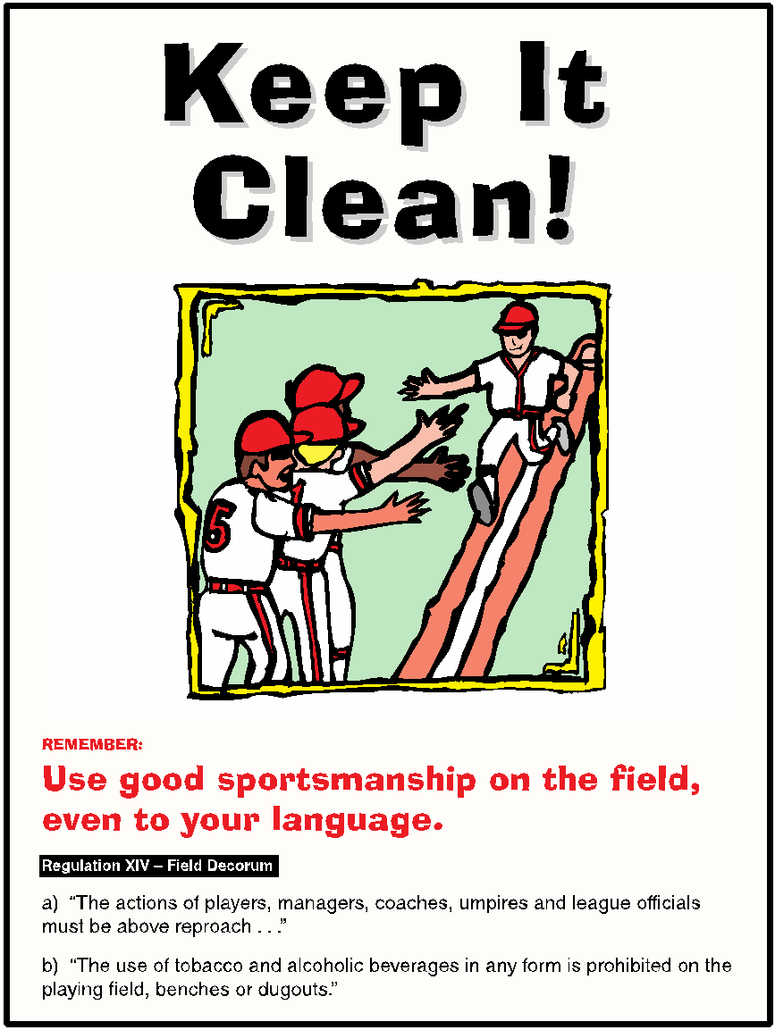
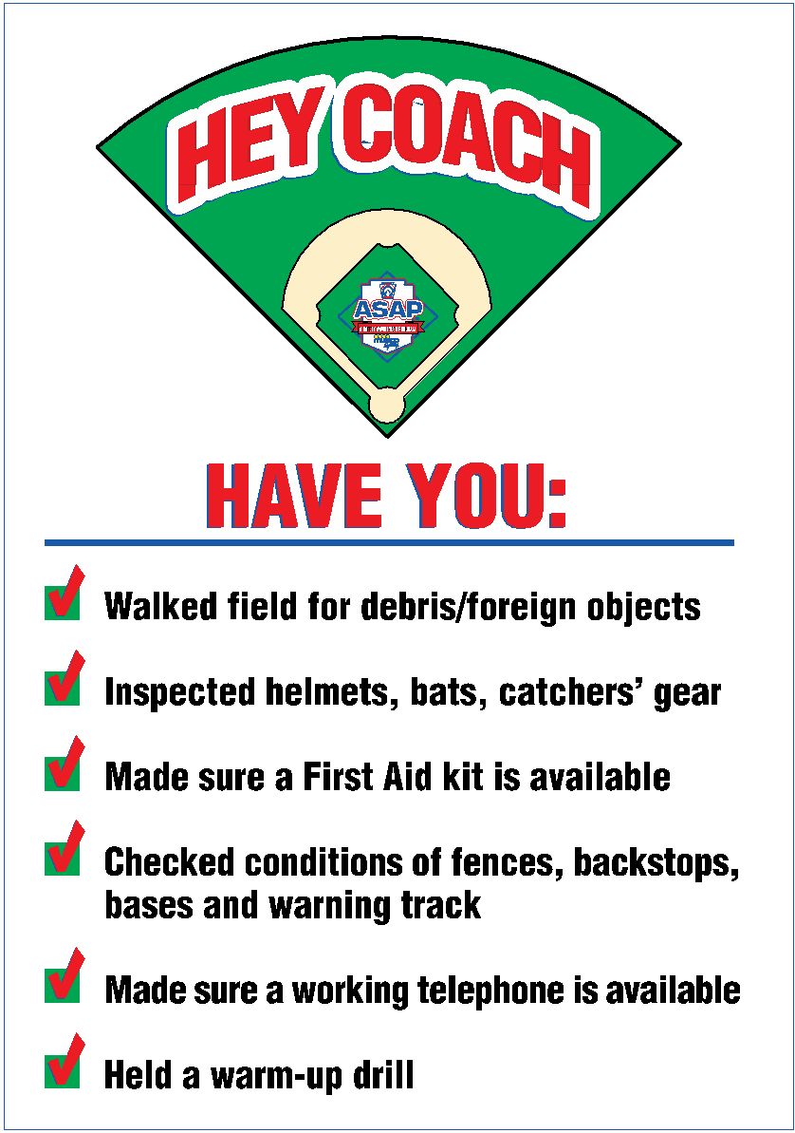
Suggested Warm Up Drills
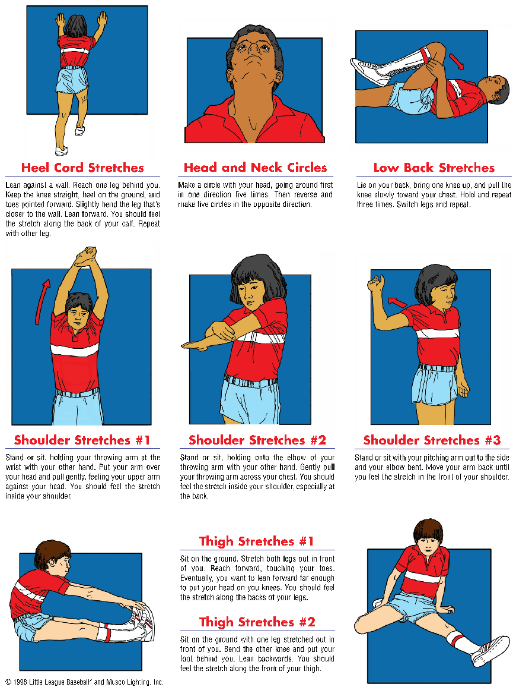

Conclusion
Read your rule book! Know your game prior to starting your season. If you need advice or help in training your Players, please ask! Little League has many resources available to help make your coaching experience a good one.

Report all information, as required, and in a timely manner, to the appropriate person/people.

Attend league meetings so that you and your team stay well informed.

Remember your codes of conduct. We are not here for our own personal gain in any way. We are only here for the children of this league.

A Quote to Live by:

Fifty years from now, it won’t matter who struck out, who dropped the fly ball, who hit the home run, or how many wins and losses your Little League team had. But the world could be different if you were important in a child’s life, yours or someone else’s.

~ AL & AL
(Al Herback & Al Price)
Little League, Inc.

HAVE A FANTASTIC, FUN, SAFE SEASON

We, the members of the West End Little League Board of Directors, appreciate all of your time and dedication to this program. Thank you for your efforts and hard work!

